1. Write a query to get a Product list (id, name, unit price) where current products cost less than $20.

Ans.

SELECT ProductID, ProductName, UnitPrice

FROM Products

WHERE UnitPrice<20 AND Discontinued=0;

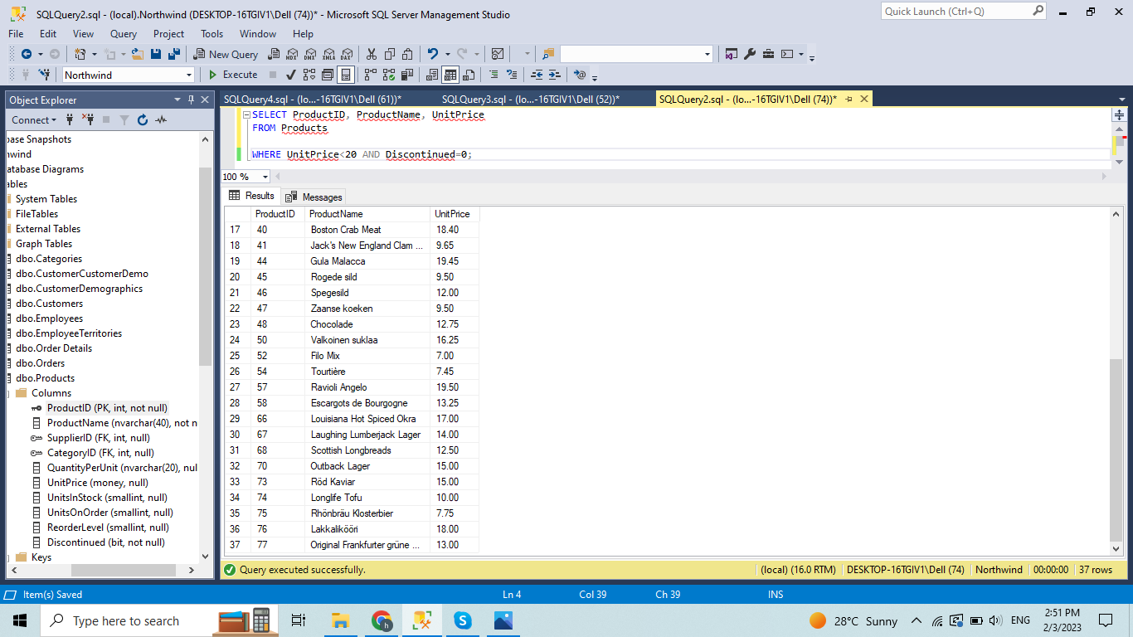

1. Write a query to get Product list (id, name, unit price) where products cost between $15 and $25

Ans.

SELECT ProductName, UnitPrice

FROM Products

WHERE (((UnitPrice)>=15 And (UnitPrice)<=25)

AND((Products.Discontinued)=0))

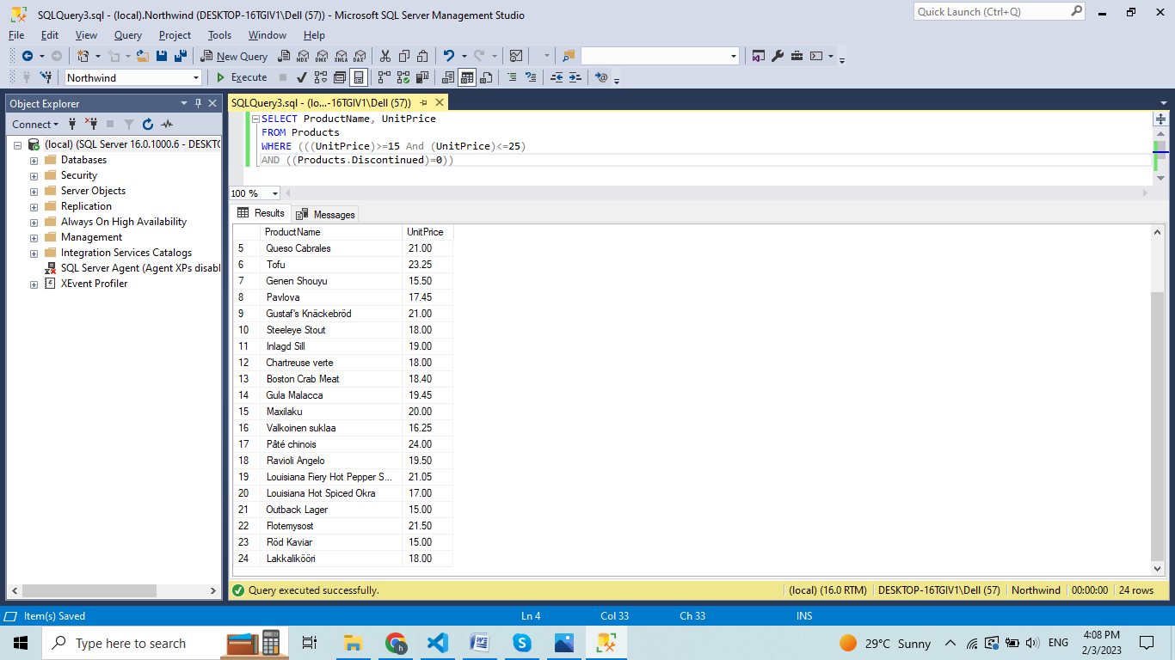

1. Write a query to get Product list (name, unit price) of above average price.

Ans.

SELECT ProductName, UnitPrice

FROM Products

WHERE UnitPrice > (SELECT avg(UnitPrice) FROM Products)

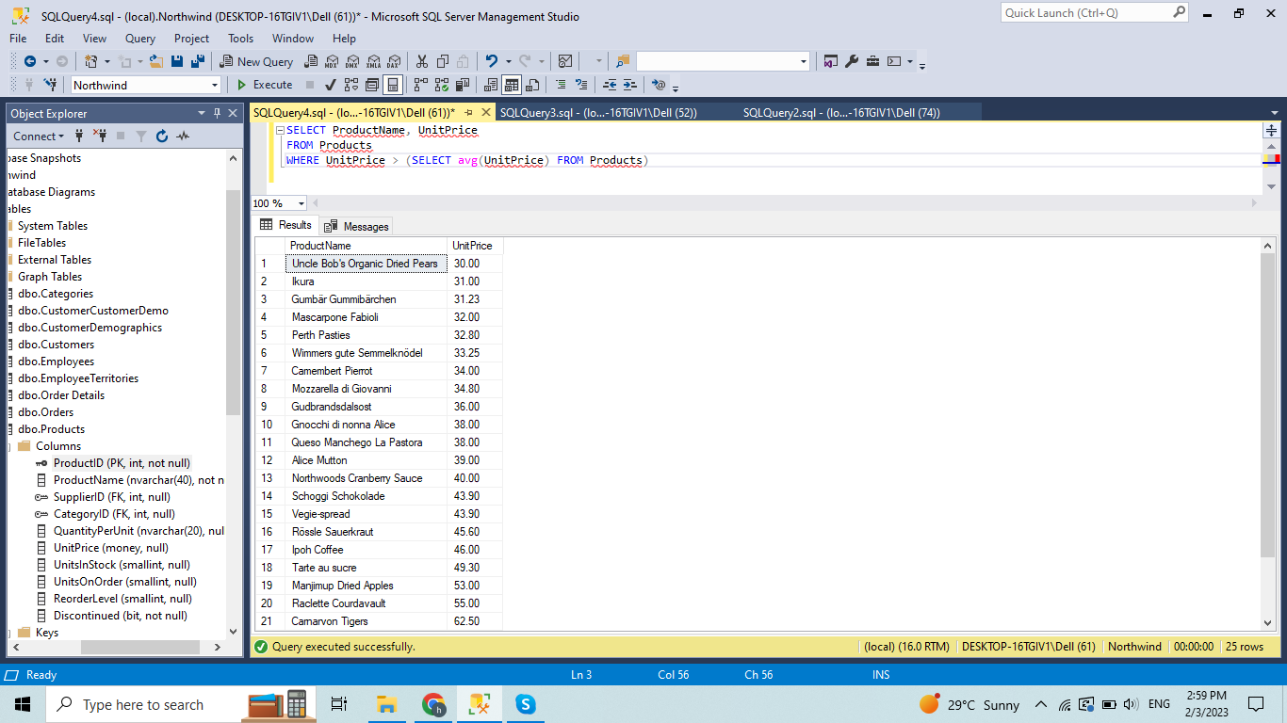

1. Write a query to get Product list (name, unit price) of ten most expensive products

Ans.

SELECT ProductName as Ten_Most_Expensive_Products, UnitPrice

FROM Products AS a

WHERE 10 >= (SELECT COUNT(DISTINCT UnitPrice)

FROM Products AS b

WHERE b.UnitPrice >= a.UnitPrice)

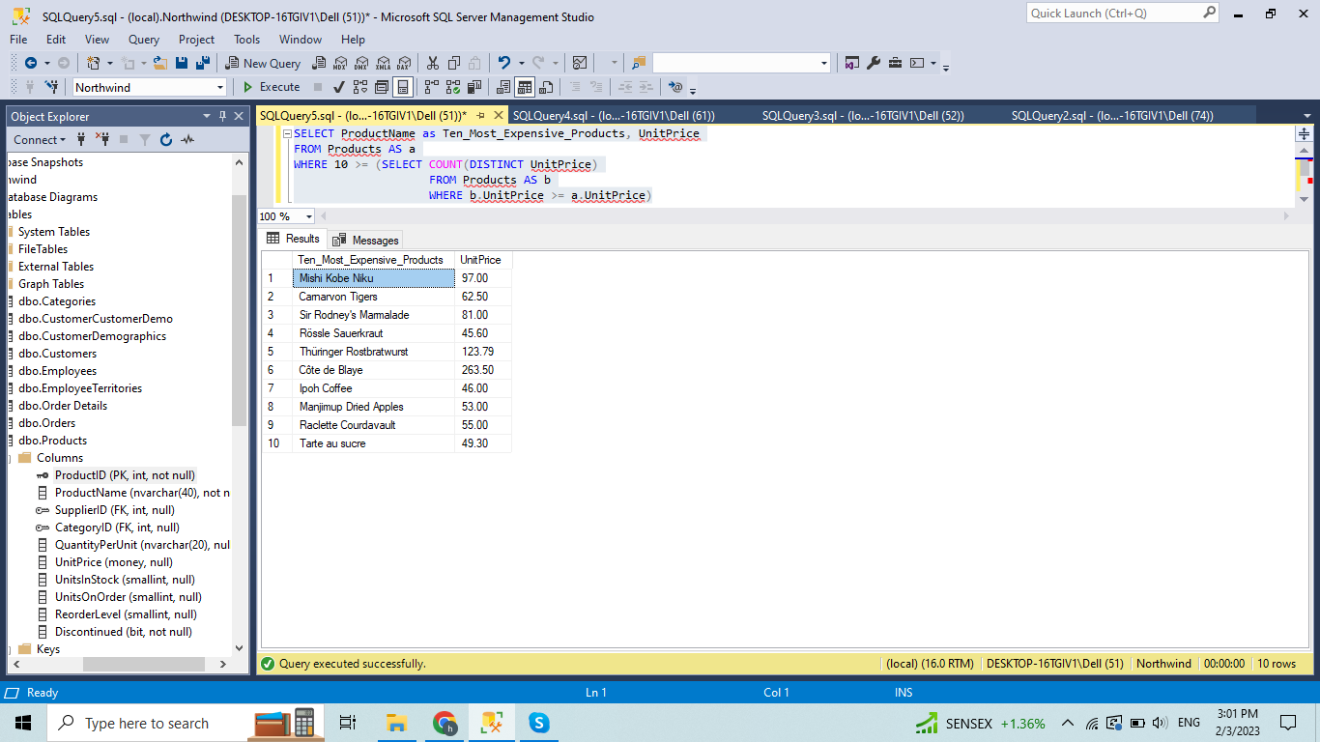

1. Write a query to count current and discontinued products

Ans.

SELECT COUNT(Discontinued) AS CurrentProducts

FROM Products

WHERE Discontinued=0

SELECT COUNT(Discontinued) AS DiscontinuedProducts

FROM Products

WHERE Discontinued=1

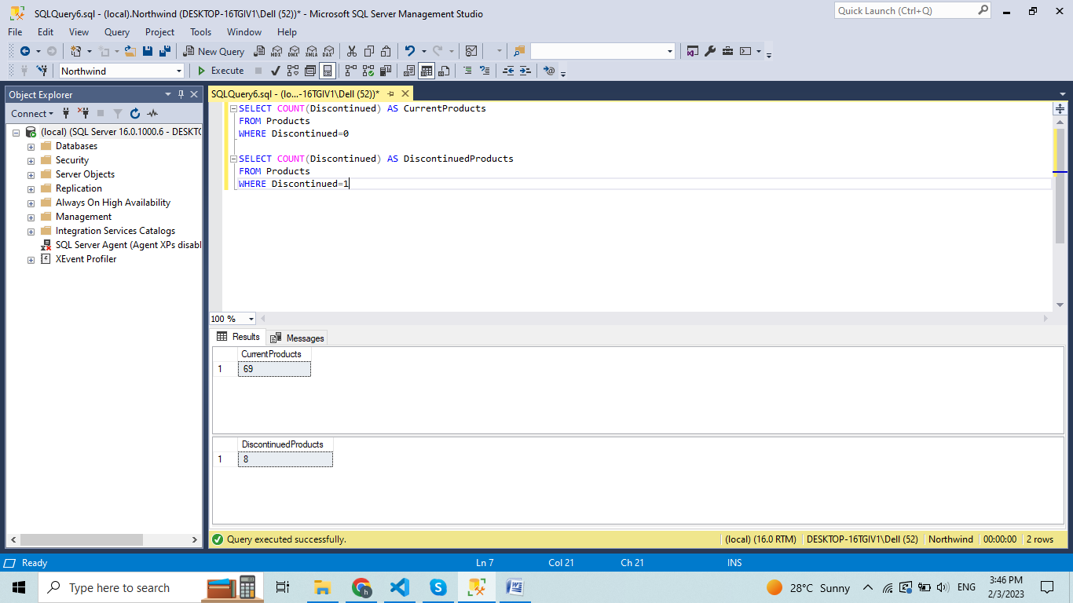

1. Write a query to get Product list (name, units on order , units in stock) of stock is less than the quantity on order

Ans.

SELECT ProductName, UnitsOnOrder , UnitsInStock

FROM Products

WHERE Discontinued=0 AND UnitsInStock<UnitsOnOrder;

